EXP NO: 1
LIBRARY MANAGEMENT SYSTEM

Aim
To develop a Library Management website to manage book issuing and returning using student name and book name.
Procedure
- Create the webpage using HTML and CSS.
- Provide input fields for student name and book name.
- Add a dropdown to select the operation, such as issuing or returning a book.
- Add a submit button to process the selected operation.
- Execute the webpage in a browser and verify the output.
Code
<html>
<head>
<title>Library</title>
<style>
body{font-family:Arial;text-align:center;background:#f2f2f2;}
div{width:250px;margin:auto;background:#fff;padding:15px;}
input,select,button{width:100%;margin:5px 0;padding:8px;}
</style>
</head>
<body>
<h2>Library Management</h2>
<div>
<input id="n" placeholder="Student Name">
<input id="b" placeholder="Book Name">
<select id="a">
<option>Issue Book</option>
<option>Return Book</option>
</select>
<button onclick="lib()">Submit</button>
<p id="r"></p>
</div>
<script>
function lib(){
let n=document.getElementById("n").value;
let b=document.getElementById("b").value;
let a=document.getElementById("a").value;
if(n==""||b=="")
alert("Enter details");
else
document.getElementById("r").innerHTML=
a+" Successful!<br>Student: "+n+"<br>Book: "+b;
}
</script>
</body>
</html>
Output
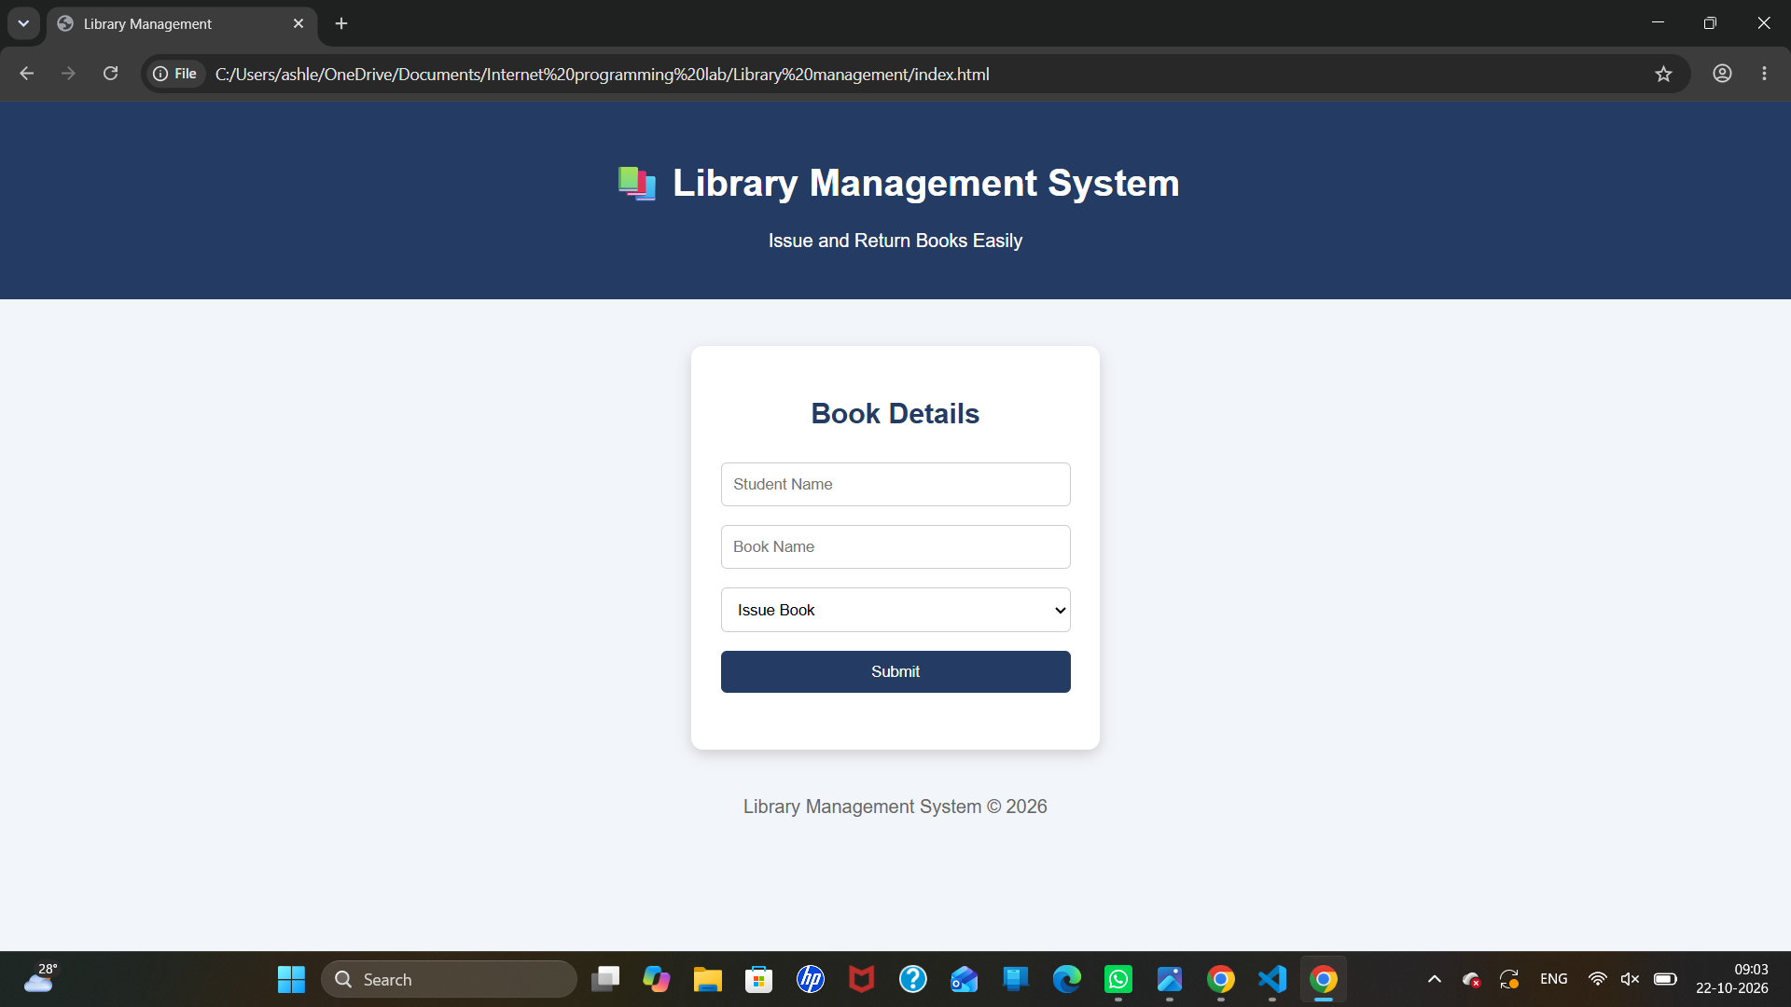

Result
Thus, the Library Management webpage was created successfully with input fields for student name and book name, a dropdown for selecting book operations, and a submit button.

